ANNUAL PAROCHIAL CHURCH MEETING

SUNDAY, 27TH SEPTEMBER 2020

The following nominations have been received:

ELECTION FOR A CATHEDRAL WARDEN

- Daniel Chumbley

ELECTION OF ONE MEMBER OF THE CONGREGATION TO MEMBERSHIP OF THE CHAPTER

- Helen Quintrell

ELECTION OF SIX MEMBERS OF THE CONGREGATION TO MEMBERSHIP OF DEANERY SYNOD

- John Beynon
- Andrew Heaton
- Linda Ridgers-Waite
- Guy Rowston

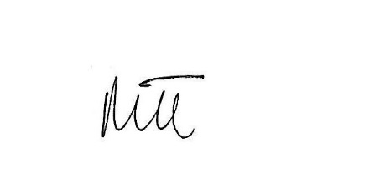

Marie Tims
Secretary to the APCM

24th September 2020

